2. Creating and manipulating database table using SQL DDL commands.

Create a database
create database test_db;
use test_db;
show databases;
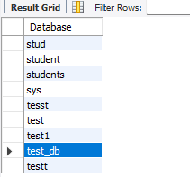

Create a Table
create table employees(emp_id int,emp_name varchar(100),city varchar(50));
desc employees;
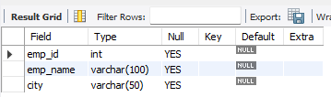

Alter table-Add column
alter table employees add department varchar(50);
select*from employees;
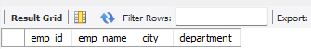

Raname Column
alter table employees rename column emp_name to full_name;
select*from employees;
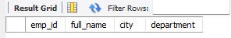

Truncate Table
truncate table employees;
select*from employees;
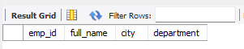

Drop Table
drop table employees;
show tables;

